

Metering Charges

(Must Reads)
Effective from 01 June 2025

CONTENTS
Contents
CONTENTS 2
Foreword 3
www.northerngasnetworks.co.uk 3
1. Introduction 3
2. Charges effective from 1st June 2025 3
2.1 Introduction 3
2.2 Must Reads 3

Foreword

This booklet sets out the metering charges that Northern Gas Networks Limited will apply for services provided under the Uniform Network Code from 01 June 2025.
The diagram below shows Northern Gas Networks Limited’s operational area.
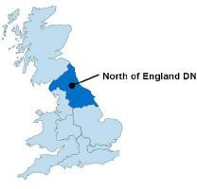

The latest version of this publication is available from Northern Gas Networks website at

www.northerngasnetworks.co.uk

Introduction
Northern Gas Networks Limited provides gas transportation throughout its area of operation.

This publication sets out Northern Gas Networks Limited’s charges from 01 June 2025 for the must read metering service provided under the Uniform Network Code.

Charges effective from 1st June 2025

Introduction

This section sets out the charges for the Uniform Network Code. This document does not override or vary any of the statutory, licence or Uniform Network Code or other contractual obligations upon Northern Gas Networks Limited.

Must Reads

The provision of meter reading services to shippers where the shipper has failed to obtain a read as defined in the Uniform Network Code (UNC) Transportation Principle Document (TPD) Section M3.6. Invoice arrangements for such reads are managed through Xoserve on behalf of Gas Transporters in accordance with UNC TPD Section S arrangements.

 | Cost
(W07) Must Reads | £71.18

