IT Hardware, Software and Consumables

RFP
Scope of Requirements
The Project/Scope of Requirements
ALL COMMUNICATIONS MUST BE SENT VIA THE ARIBA E-PROCUREMENT SYSTEM
You are invited to tender after being shortlisted as part of the PQQ process.
This RFP is being conducted in line with the Utilities Contact Regulations 2016 using the negotiated procedure via Achilles UVDB qualification system notice.
Project Scope (Works Information)
The purpose of this contract is for a selection of suppliers to be contracted under a Framework for the supply and delivery of IT Hardware, Software and Consumables (“Opportunity”) across our delivery locations (subject to change) across the NGN network.

The current expectations are to add up to five (5) partners (dependant on tender qualification and subsequent award) to carry out the supply to NGN.

The IT Hardware, Software and Consumables Framework is to include (but is not limited to) products such as:
- IT Hardware e.g. laptops, tablets, phones, servers
- IT Software Licences (Off the Shelf software Products and support and maintenance)
- Data media Storage Products e.g. CD’s, DVD’s, Memory Sticks
- Networking Items e.g. cables, routers, access points
- Audio-visual Equipment
- IT Consumables
- Chargers & USB cables
- Encrypted USB sticks
- Video adapters / video cables
- Wireless keyboard & mice
- Phone holders
- Printer ink
- Microphone Headsets
- Docking Stations & adaptors

NGN’s current core items are listed below. This is not a fully exhaustive list but a sample of the type of products NGN will purchase under this Framework.
- Lenovo ThinkPad T14 Gen 4
- Samsung Galaxy Tab Active 4 Pro
- Samsung Galaxy XCover6 Pro
- ASUS VP279HE 27" Full HD Monitor
- Alogic USB-C Docking Station MX2 - 100w Edition
- Epson WorkForce WF-110W
- Logitech MK270 Wireless Mouse and Keyboard set
- Logitech M185 Wireless Mouse
- 2 metre USB C to USB C cable
- Dual USB A + USB C in car adapter
- 65w USB C Laptop Power Adapter
- Zebra Ribbon YMCKOK
- MIFARE DESFire EV2 2K Cards
- EPOS | Sennheiser ADAPT 165 USB II Headset
- Comms PC with below spec (usually purchased through https://www.in-carpc.co.uk)
- CQ57L Vehicle PC Base Platform
- 8 GB Extended Temperature RAM
- 128 GB Extended Temperature SSD
- 2x Internal 4G module with fallback to 3G
- Windows 10 Pro 64-bit
- 4x Wall-Mount Antenna with Bracket

NGN are looking for suppliers to participate in a process for the quotation, purchase, supply and delivery of IT Hardware, Software and Consumables. This process will need to include (but may not be limited to) the below requirements:
- System based (email) method of requesting a quote
- Suppliers must quote on all requests – large and small
- Dedicated contact (email and phone details)
- Quotation turnaround time of 2 business day (based on a 9 hour day)
- Quotations to include stock availability and delivery times but all quotations must include free delivery
- Technical advice and suggestions on alternatives to what we are getting quotes for (i.e if a product has been superseded or in short supply etc). We often use Amazon as a guide to what we are wanting, but if there is a better product, or a product that has more availability, we would expect to be advised
- Supplier to reserve stock for up to 1 week minimum to ensure supply based on our authorisation process
- Free delivery on ALL items and delivery within 3 working days (unless other delivery date is specified and agreed at quotation stage)
- Supplier working hours to be in line with NGN working times (Monday to Friday 08:30 to 17:30)
- Weekly summary via email of all outstanding orders
- Details of the supplier’s escalation process and kept up to date by the supplier
- Details of the supplier’s Supply Chain escalation process and kept up to date by the supplier
- Return of faulty / damaged / not required items
- Proof of Delivery
- Accreditation status with major suppliers (Dell / Lenovo / Microsoft / Samsung / other)

Invoicing
All individual invoices should be submitted per Purchase Order with a clear description relating to the purchase, and a PO number.

Account Management
NGN require a monthly summary of any outstanding purchase orders still awaiting payment, along with summary of all outstanding orders.

Alongside monthly reports, quarterly Service Reviews with key NGN business stakeholders will be required.

Framework partners will also be required to work with our account management teams at Dell, Lenovo, Microsoft, Samsung, EPOS Sennheiser.

Appendix 1 – Colleague Care Team Procurement (for suppliers)
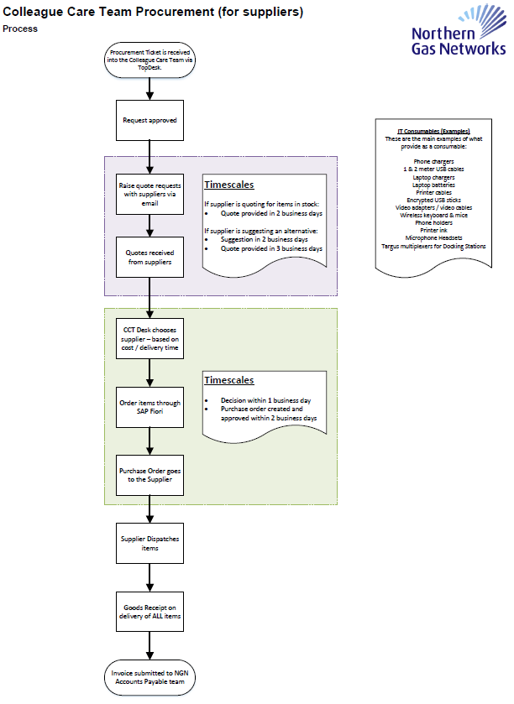

Estimated Contract Timings

The period of any contract(s) resulting from this procurement will be 3 years
The length of the contract may be extended by NGN for a further 3 x 1 years
Start date estimated as November 2024.

Tender Assessment / Evaluation

The award will be based upon price & quality ratio. It is the intent that the award will deliver to NGN the total best value. The top 5 scoring Suppliers will be awarded a place on the Framework.

The evaluation criteria is 50% commercial, 50% non-commercial. The individual scores for each section is indicated against the questions in the evaluation criteria document.

The assessment of price will be carried out independently of the quality assessment and scored against the methodology stated in the evaluation criteria within the RFP question document.

Price will also be requested for each individual purchase under the Framework to ensure that competitive pricing is presented throughout the duration of the Framework.

NGN intend to appoint multiple Suppliers on to a framework to provide the requirements as set out within this Tender as the most economically advantageous outcome.

Important Note
NGN reserves the right to award a place on the Framework to any bidder that scores within 3% of the fifth placed bidder unless there are exceptional reasons.

Evaluation Panel

2.7 Evaluation Panel
NGN’s team to perform the evaluation of this tender process comprises the following:
Name | Department
Becky Handforth | Procurement
Kitty Blyth | Procurement
Alex Walsh | Legal
Alex Haden | Colleague Care
Mark Lawrence | Colleague Care

Timetable

2.6 Scoring Methodology

For qualitative questions NGN will score on the following basis

Points | Interpretation
9-10 | Excellent – Overall the response demonstrates that the bidder exceeds all areas of the requirement and provides all of the areas evidence requested in the level of detail requested. This, therefore, is a detailed excellent response that meets all aspects of the requirement leaving no ambiguity as to whether the bidder can meet the requirement.
6-8 | Good - Overall the response demonstrates that the bidder meets all areas of the requirement and provides all of the areas of evidence requested and any omissions in relation to the level of detail requested in terms of either the response or the evidence are trivial. This, therefore, is a good response that meets all aspects of the requirement which but may have a trivial level ambiguity due the bidder’s failure to provide all information at the level of detail requested.
3-5 | Adequate - Overall the response demonstrates that the bidder meets all areas of the requirement, but not all of the areas of evidence requested have been provided. This, therefore, is an adequate response, but with some limited ambiguity as to whether the bidder can meet the requirement due to the bidder’s failure to provide all of the evidence requested.
1-2 | Poor – The response does not demonstrate that the bidder meets the requirement in one or more areas. This, therefore, is a poor response with significant ambiguity as to whether the bidder can meet the requirement due to the failure by the bidder to show that it meets one or more areas of the requirement.
0 | Unacceptable - The response is non-compliant with the requirements of the ITT and/or no response has been provided.

Tender Response
Responses must be submitted within the timeframe via the Ariba Portal as a response to Section 2 - tender questions (responses should not be submitted via the Ariba messaging portal) with all attachments saved in a zip file, if you experience any technical difficulties please contact the person names in this document.

All bidders will be notified of outcome and provided feedback by the date specified on the procurement timetable.

